February 10, 2020

To whom it may concern:

Confirmation of products produced by Clark-Reliance Corporation at the 16633 Foltz Parkway, Strongsville facility under a quality management system meeting the requirements of ISO 9001:2015 which is certified by HSB Registration Services, Certificate of Registration #Q 1718.

The items produced and available during surveillance audits, without restriction, are:
Separators, Process Skid systems, Filters, direct and remote view Level Gauges and their associated process valves, Level Switches, Level Transmitters, direct view and remote indication Boiler Trim Gauges & Systems, Sight Flow indicators, Illumination devices for the various sight gauges and direct view indicators and Transfer Valves.

Note:
The models and types of products are available by contacting Clark-Reliance Corporation or by visiting their web site.

Sincerely,

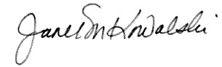

Janet Kowalski
Operations Manager

